|  |  |
| --- | --- |
|  | **“GOOd For You”** |

**Team Members:**

**Mansi Padhiyar (0901509)**

**Jenab Vohra (0904905)**

**Jay Mangnani (0904910)**

**Nihal Gupta (0959636)**

**Kalyan Chintaguntla (0906298)**

**Submitted to:**

**Prof. Nancy**

**Introduction**

This document is all about the implementation plan of the solution we choose in the last document. The risk register for Merger and Acquisition following by its consequences, probability, impact, risk levels, plan to modify it and who is the owner of that responsible risk. Second deliverable is high level project plan for merger and acquisition followed by stakeholder list. Final deliverable is of the meeting plan.

**Risk Register**

|  |  |  |  |  |  |  |
| --- | --- | --- | --- | --- | --- | --- |
| **Risk** | **Consequences** | **Probability** | **Impact** | **Risk Level** | **Risk Modification Plan** | **Risk Owner** |
| Insufficient power and water supply | Lack of electricity may reduce the quality of the food specially the refrigerators which are being used.  Water is important to maintain cleanliness and hygienic working environment as well as to ensure clean food. | 40% chances if employees don’t follow the daily work schedule | Medium impact | **Mitigate Risk**  Reduce the probability of the risk by risk modification plan | To avoid this risk, we can store enough water inside the truck.  We can purchase the generator in case of power cut.  Get the permission from the authorities to use electricity and water supply. | Food truck owner  Supervisor |
| Fire Hazard | Constant mot  ion of the truck can cause the connections to weaken, high possibility of leaks and fire  Grease traps and exhaust system where grease can build up can also create a threat of fire. | 100% chances because of carelessness | High impact | **Transfer risk**  accept the risk, but all or part of the liability is moved to a third party that is insurance company. | Property damage insurance protects the property from collision, theft, fire and other damages while vehicle is parked.  Regular inspection, proper maintenance such as cleaning the grease every time after cooking, making sure no fuel or lighter near to the gas can avoid this risk. | Insurance company |
| Operator risk / working hazards | As employees are the largest asset and backbone of the food truck business, there is always high possibility of accidents such as falls, burns, cuts | 100% chances due to fatigue, carelessness or lack of training | High impact | **Transfer risk**  We accept the risk, but all or part of the liability is moved to a third party that is insurance company. | Workers Compensation insurance  To prevent such accidents proper safety equipment such as gloves and anti slip shoes is necessary.  Proper training is also must. | Insurance company  Employer |
| Location/ robbing | If the food truck is not located at a safe place, then there is the chance of getting robbed, which may take a significant impact on operating costs. | 30% chances. Nil in case, we did get parking clearance at a secured place | Medium  Impact | **Transfer Risk**  We will be taking insurance and will hire security service for the safety of employee and assets | To avoid risk, we can hire a security guard | Insurance Company |
| Food Contamination/ Wastages | Some times food can be contaminated and It may be used up by our cook for preparation of food. Due to less demand, raw food items will be kept for a long time, this will increase our wastage. | 40% chance in case of bad weather and less crowded day. | Medium | **Avoid Risk**  This risk should be avoided because it may impact revenue costs. | We will be avoiding wastages by regularly checking the expiry dateof packed food items and keeping demand and supply of inventory in balance. | Inventory manager |
| Sudden changes in licensing framework that resulted from political or economic changes | Delay processing of legal work like taking permits, certificates, etc. Hike in licensing fee can result in an increase of licensing cost | 20% Chances incase employer is not following the business news, trends or forgot to process for permits. | Low | **Accept Risk**  Licensing and other permit are needed for running a business. We have to adapt to the new framework | Planning for permits and other legal work in advance. | Employer |

**High level project plan**

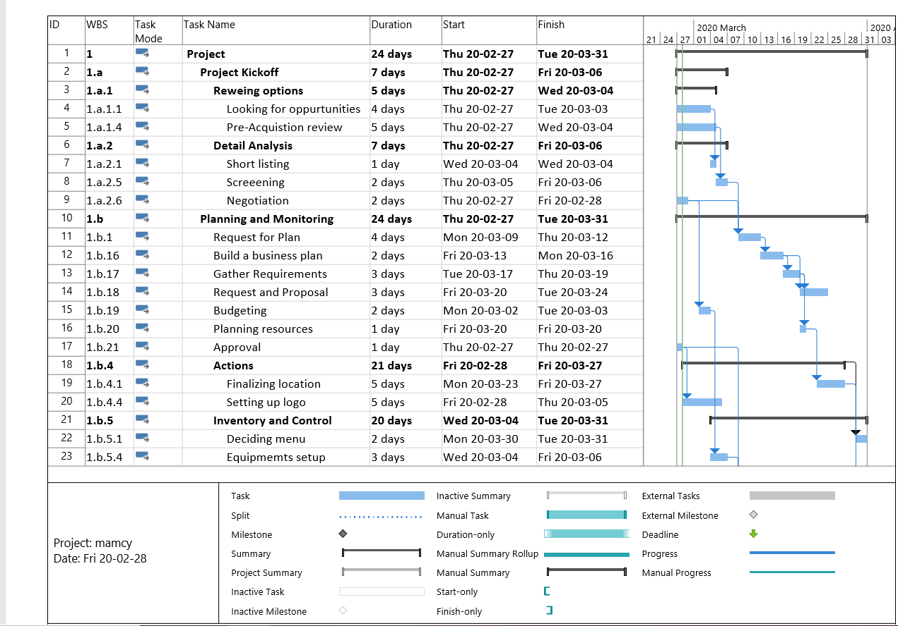

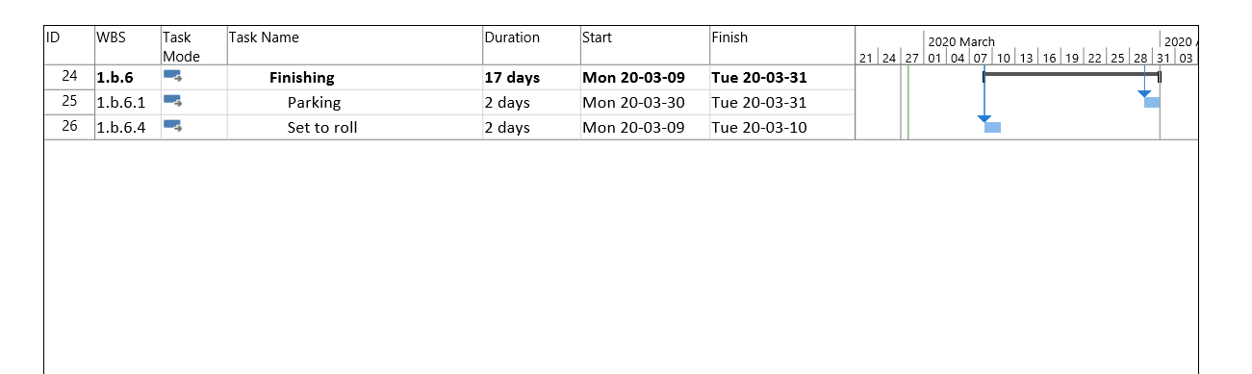

**Stakeholder Lists**

|  |  |
| --- | --- |
| **Stakeholder** | **Roles and Responsibilities** |
| Owners | -bonding with the other owners  -have collaborative nature  -offering time and money equally  **Role: Partners** |
| Employees | -involve in day to day activities  -improve skills and perform well  -maintain the equality for both companies  -manages the due diligence process  -pay attention to the customer satisfaction.  - **Role: Performer (ambassador)** |
| Customers | -Giving review  -increasing profit  **Role: Consumers** |
| Top level management or managers | -involved in integration planning  -involved in the process to provide strategic guidance  -ensure to point out the red flags and opportunities in the business  **Role: Decision Maker** |
| Restaurant owners with whom collaborating | -offer equality of profit share  -equal investment  -signing agreement with the company brand name  -legal documents for merger.  **Role: Collaborator** |
| Supplier | -Bonding with the owner  -Supplying all the essentials to serve the need  -Can have profits if there is a good relation between owner and supplier  **Role: supplier** |
| Competitors | -Other truck vendors are the competitors  -They will have an impact on the profits of our food truck.  -They access the business and makes sure they attract people.  **Role: Competitors.** |
| Licencing agents | -Responsible for truck licensing.  -Parking fees and issues.  -Government are also considered as stakeholders as they collect taxes.  **Role: license agents** |
| Communities | -Communities plays major role in business located near them.  -They work as sort of mediators and publicity which helps to grow business.  **Role: Marketing** |

**Meeting plan**

|  |  |  |  |  |
| --- | --- | --- | --- | --- |
| **Tasks** | **Meeting Title** | **Description** | **Inputs** | **Outputs** |
| Project Kick off | Kick- off meeting | The very first meeting where you get the project allocated with the team member taking part in it. | * Brief project overview * Introduction of team members | * Project concept * Team members * Weekly stand ups * Working sessions |
|  | Team -building meeting | The meeting where you get to know your team strength and weakness | * Showing off the skills | * Work distribution * Resource allocation requirement list |
| Reviewing options | Innovation meeting | This meeting decided that how innovative we can get our project to be valued in market and earn profit accordingly | * Budget review * Stakeholder list | * Lists of companies involved loss * Lists of companies looking for merger &acquisition |
|  | Progress Check meeting | This meeting is just to make a check about so the team is working so far. | * -Project introduction * Stakeholder analysis * Review analysis | * Checklist report of the things done so far |
| Details analysis | Research & Analysis meeting | This meeting will represent about the 2 -3 best alternatives with the detail analysis and choose one of them. | * Focus on 2-3 alternatives * Cost -benefit analysis * Requirement specifications | * One best solution to carry merger and acquisition in most profitable manner |
|  | Planning meeting | This meeting will decide the planning and designing of project. | * Business use case * Cost benefit ratio * Pay back period analysis * Workflow of the project | * A detail flowchart of how business will business run, and risk factors attached to it |
| Planning and monitoring | Implementation meeting | This meeting is how the plan is going to execute in following weeks. | * Flowchart * Risk analysis register * Use cases * Business data diagram * Cost analysis | * Purchasing of the equipment needed and complete legal formalities * Implementing plan |
|  | Progress check meeting | This meeting is just to make a check about so the team is working so far. | * Check list provided with all pending work | * Completing with pending work and back to track |
| Actions | Required Actions Meeting | This meeting is about any action left over in previous meeting to cover. | * Setting up the options for locations * Risk register * Multiple object analysis * Sensitivity analysis | * Finalize the location and logo |
| Inventory and control | Production Control meeting | This meeting will be about gathering of equipment with the external supplies cost and budgeting | * Budget for external supplies | * Purchasing the supplies and make checklist document for it. |
|  | Problem solving meeting | This meeting to remove the obstacles so far in the project | * Business requirement design, budgeting, risk matrix | * Requirement Work plan, traceability matrix |
| Finishing | Broadcast meeting | This meeting is all about the final check and start to roll-out | * Implementing plan | * Set the truck at parking place |
|  | Training meeting | This is the final meeting for the employees training | * Checklist document | * Project goes under maintenance. |